UNIVERSITY OF BUEA
Faculty of Engineering and Technology
Department of Computer Engineering
CEF 440 Internet and Mobile Programming
App Identity ,Visual Design and Frontend Implementation
Design and Implementation of a Mobile Application for Car Fault Diagnosis
Group Members
Full Name | Matricule
AWA PRECIOUS | FE23A019
GUIMAZEU KENFACK DANIELLE | FE23A067
NGANE IDRISS AJANG | FE23A110
TACHINDA NJIGONG TRESOR | FE23A147
TAMBE ENOWTABI PRINCELY | FE23A155

Supervisor: Dr. Valery Nkemeni | Academic Year: 2025/2026

Table of Contents
1. Introduction
2. App Identity
2.1 Application Identifiers
2.2 Platform Targets
2.3 Versioning Scheme
2.4 Signing Configuration
2.5 Visual Identity Summary
3. Visual Design
3.1 Design Objectives
3.2 Design Principles
3.3 Colour Palette
3.4 Typography
3.5 Navigation Design
3.6 User Interface Components
3.7 Screen Wireframes
3.8 Screen Mockups
4. Frontend Implementation
4.1 Project Setup
4.2 Project Structure
4.3 Screen Implementations
4.4 Testing
5. Conclusion

1. Introduction
This report documents the full design and implementation process of CarDiag, a cross-platform mobile application developed by Group 12 for the CEF 440 Internet and Mobile Programming course at the University of Buea. The report is organized into three main parts.
The first part, App Identity, defines the technical and visual identity of the application: its unique identifiers, platform targets, versioning scheme, colour palette, typography, logo, icon, and splash screen design.
The second part, Visual Design, describes the design objectives and principles that guided the interface, the navigation structure, the reusable UI components, the wireframes that map the layout of each screen, and the high-fidelity mockups that represent the final visual appearance of the application.
The third part, Frontend Implementation, documents the React Native codebase: the project setup, the folder structure, the navigation configuration, the implementation of each screen, and the reusable components built for the application.
CarDiag assists vehicle owners in identifying vehicle faults, understanding dashboard warning lights, recording engine sounds, reading diagnosis results, and finding repair tutorials. The application targets both Android and iOS devices using a single React Native codebase.

2. App Identity
App Identity is the set of all elements that define what CarDiag is, how it is recognised by users, and how it is uniquely identified by operating systems and application distribution platforms. It covers both technical identifiers used by the system and visual elements seen by the user.

2.1 Application Identifiers
The table below lists the core technical identifiers that uniquely define CarDiag on all target platforms.

Field | Value
Application Name | CarDiag
Full Name | CarDiag Car Fault Diagnosis App
Package Name (Android) | com.group12.cardiag
Bundle ID (iOS) | com.group12.cardiag
App ID | cardiag_group12_cef440
Version Name | 1.0.0
Version Code | 1
Build Type | Debug (Development) / Release (Production)

2.2 Platform Targets
CarDiag targets both Android and iOS through a single React Native codebase. The table below defines the SDK levels, permissions, and screen orientation requirements.

Parameter | Value
Target Platform | Android and iOS (Cross-platform)
Framework | React Native
Target SDK (Android) | Android 13 API Level 33
Minimum SDK (Android) | Android 8.0 API Level 26
Target iOS Version | iOS 14 and above
Minimum iOS Version | iOS 8
Screen Orientation | Portrait (primary), Landscape (optional)
Internet Permission | Required for diagnosis, tutorials, and sync
Bluetooth Permission | Required for OBD-II adapter connectivity
Camera Permission | Required for dashboard warning light scanning
Microphone Permission | Required for engine sound recording

2.3 Versioning Scheme
CarDiag follows Semantic Versioning (SemVer) using the format MAJOR.MINOR.PATCH. The current release is version 1.0.0, which represents the initial build. The version name is shown to users on the About screen. The version code is an integer that increases by one with each build submitted to the Play Store or App Store. The two values serve different purposes: the version name communicates the release to users while the version code is used by the platform to detect updates.

2.4 Signing Configuration
Every build of CarDiag is signed with a keystore file. This signature guarantees the authenticity and integrity of the application package. The debug keystore is created automatically by Android Studio for local development. The release keystore is generated by the team and kept secure outside version control. If the release keystore is lost, it becomes impossible to publish updates to the Play Store under the same package name. For iOS, a provisioning profile and distribution certificate serve the same purpose.

2.5 Visual Identity Summary
The table below gives a consolidated reference of all visual identity values used throughout the application.

Identity Element | Value
App Name | CarDiag
Package Name | com.group12.cardiag
Version | 1.0.0 (build 1)
Platforms | Android 8.0 and above / iOS 8 and above
Framework | React Native
Primary Colour | #1E88E5 Electric Blue
Background Colour | #0A1628 Deep Navy
Accent and Warning | #FF6D00 Warning Orange
Primary Font | Inter Bold (headings)
Body Font | Roboto Regular
Code Font | Roboto Mono
Logo | Tachymetre symbol with wordmark and tagline
Icon | Tachymetre symbol only, no text
Tagline | SMART CAR FAULT DIAGNOSIS
Team | Group 12 University of Buea 2025/2026

3. Visual Design
This section documents the design decisions taken to produce the CarDiag interface. It covers the design objectives, the guiding principles, the colour system, the typography, the navigation structure, the reusable UI components, the wireframes for each screen, and the final mockups.

3.1 Design Objectives
The visual design of CarDiag was developed to meet the following objectives:
• Produce a modern and professional interface that communicates automotive diagnostics clearly.
• Give users direct access to key features without navigating through multiple layers.
• Keep diagnostic information readable and well structured on small mobile screens.
• Maintain visual consistency across all screens through a shared component library.
• Support both Android and iOS devices without two separate designs.
• Provide immediate visual feedback after user actions such as scanning, recording, and diagnosing.

3.2 Design Principles
Four principles governed every design decision made for CarDiag.

Simplicity
Each screen is built around a single task. The user can access any major feature from the bottom navigation bar without going through intermediate screens. Labels, icons, and buttons are clear and require no explanation.

Consistency
Buttons, input fields, cards, status badges, and navigation elements share the same visual style across all screens. A user who learns one screen immediately understands the others.

Accessibility
Text sizes, colour contrast ratios, and touch target sizes were chosen to ensure readability and ease of interaction for all users, including those with reduced vision.

Feedback
The application provides clear visual feedback for every user action. Scanning shows a live viewfinder with corner markers. Recording shows a live waveform and a timer. Diagnosis displays a colour-coded severity badge. Completed actions show confirmation states.

3.3 Colour Palette
The CarDiag colour palette uses three primary colours. Electric Blue is the brand colour and represents technology and reliability. Deep Navy is the background colour and gives the interface a professional, high-contrast look inspired by real-world OBD diagnostic tools. Warning Orange is reserved for fault alerts, severity indicators, and the tachymetre needle, creating an immediate visual association between the colour and the concept of a vehicle fault.

Swatch | Name | Hex Code | Usage
 | Electric Blue (Primary) | #1E88E5 | Buttons, links, active states, brand elements
 | Deep Navy (Background) | #0A1628 | App background, icon background
 | Carbon Black | #070E1C | Card backgrounds, secondary surfaces
 | Warning Orange (Accent) | #FF6D00 | Fault alerts, warning indicators, needle
 | Light Blue | #42A5F5 | Highlights, secondary interactive elements
 | White | #FFFFFF | Primary text on dark backgrounds
 | Light Grey | #90CAF9 | Secondary text, subtitles, captions
 | Success Green | #4CAF50 | Normal vehicle status, completed operations
 | Error Red | #D32F2F | Critical fault states only

3.4 Typography
CarDiag uses three typefaces to cover all text roles in the application. Inter Bold handles all display and heading text. Roboto Regular handles body text, labels, button text, and input fields. Roboto Mono handles fault codes, version badges, and diagnostic tags because monospace fonts make alphanumeric codes easier to read.

Role | Font | Weight and Size | Usage
Display and Heading | Inter | Bold 700, 24 to 32sp | Screen titles, section headers
Body and UI | Roboto | Regular 400, 14 to 16sp | Body text, labels, buttons, inputs
Caption and Badge | Roboto Mono | Medium 500, 11 to 12sp | Fault codes, version badges, tags

3.5 Navigation Design
CarDiag uses a bottom navigation bar with five tabs. This structure places all major features one tap away from any screen, reducing the number of steps needed to switch tasks.

Home | Scan | History | Tutorials | Profile
Dashboard and vehicle status | Warning light scanner and engine sound | Diagnosis records | Repair guides | User account and settings

3.6 User Interface Components

Buttons
Primary buttons have a solid Electric Blue background with white text. They are used for the main action on each screen. Secondary buttons have a transparent background with an Electric Blue border and are used for secondary actions such as saving to history. Destructive buttons such as Stop Recording use a solid red background.

Cards
Cards are the main container for grouped information. They have a Deep Navy background with a subtle blue border and rounded corners. Cards are used to display vehicle status, diagnosis results, tutorials, and history records.

Input Fields
Input fields have a Carbon Black background with a blue border, rounded corners, a left-side icon for context, and a placeholder label. Password fields include an eye icon to toggle visibility. Validation messages appear below the field when input is incorrect.

Status Badges
Severity badges appear next to diagnosis results and history records. They use three colours: orange for medium severity, red for high severity, and blue for normal status. Each badge is a small pill with a coloured border and matching text.

Bottom Navigation Bar
The navigation bar has a Carbon Black background with a blue top border. The active tab is highlighted in Electric Blue. Inactive tabs use a muted dark blue. Each tab shows an icon above a short label.

3.7 Screen Wireframes
The wireframes below represent the structural layout of each screen. They show the arrangement of components without colours or visual styling, making it easier to evaluate the information hierarchy and navigation logic before applying the visual design.

Screen 1 Splash Screen
[ App logo centred ]
[ App name: CarDiag ]
[ Tagline: SMART CAR FAULT DIAGNOSIS ]
[ Loading progress bar at bottom ]

Screen 2 Login Screen
[ App name at top centre ]
[ Heading: Welcome back ]
[ Subheading: Login to continue ]
[ Email input field ]
[ Password input field with show/hide icon ]
[ Forgot password link ]
[ LOGIN button ]
[ Divider: or ]
[ Continue with Google button ]
[ Link: No account? Register ]

Screen 3 Register Screen
[ Back arrow ]
[ Heading: Create account ]
[ Full name input field ]
[ Email input field ]
[ Password input field ]
[ Confirm password input field ]
[ Terms and Conditions checkbox ]
[ CREATE ACCOUNT button ]
[ Link: Already have an account? Login ]

Screen 4 Dashboard Screen
[ Top bar: Hamburger menu | App name | Bell icon ]
[ Greeting: Hello, [Name]! ]
[ Vehicle status card: status label + car illustration ]
[ Quick actions grid: Scan / Record / History / Tutorials ]
[ Recent diagnoses: list of last 2 entries with severity badges ]
[ Bottom navigation bar ]

Screen 5 Warning Light Scanner
[ Top bar: Back arrow | Screen title | Info icon ]
[ Camera viewfinder with corner frame markers ]
[ Animated scan line ]
[ Instruction text below viewfinder ]
[ Controls: Flash icon | Capture button | Gallery icon ]
[ Bottom navigation bar ]

Screen 6 Engine Sound Recording
[ Top bar: Back arrow | Screen title | Info icon ]
[ Live audio waveform ]
[ Microphone icon ]
[ Recording status label and timer ]
[ Instruction text ]
[ STOP RECORDING button ]

Screen 7 Diagnosis Results
[ Top bar: Back arrow | Screen title | Share icon ]
[ Fault code card: code, description, severity badge ]
[ Description section ]
[ Possible causes list ]
[ Recommended action ]
[ Bottom buttons: Save to history | Find tutorials ]

Screen 8 Repair Tutorials
[ Top bar: Back arrow | Screen title | Search icon ]
[ Category filter pills: All / Engine / Electrical / Brakes ]
[ Tutorial card: icon | title | category and duration | arrow ]
[ Tutorial card: icon | title | category and duration | arrow ]
[ Tutorial card: icon | title | category and duration | arrow ]
[ Bottom navigation bar ]

Screen 9 History Screen
[ Top bar: Back arrow | Screen title | Filter icon ]
[ Filter pills: All / Warning lights / Engine sound ]
[ History entry: icon | code and description | date | severity badge ]
[ History entry: icon | code and description | date | severity badge ]
[ History entry: icon | code and description | date | severity badge ]
[ Bottom navigation bar ]

Screen 10 Profile Screen
[ Top bar: Back arrow | Screen title | Settings icon ]
[ User card: avatar initials | name | email | Edit button ]
[ My Vehicle card: car icon | make model year | arrow ]
[ Settings list: Saved vehicles / App settings / Offline data / Help / Logout ]
[ Bottom navigation bar ]

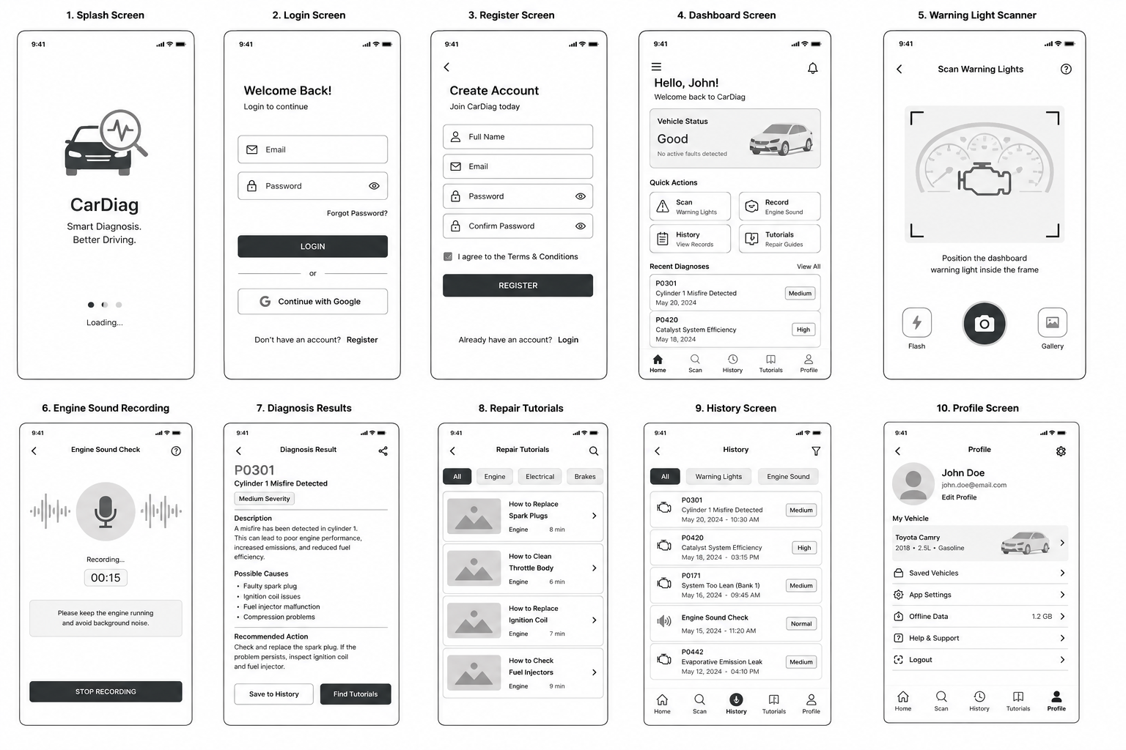3.8 Screen Mockups
The mockups below show the final visual design of each screen with the full CarDiag colour palette, typography, and component styles applied. Each mockup was designed to reflect the actual appearance of the screen on a mobile device.

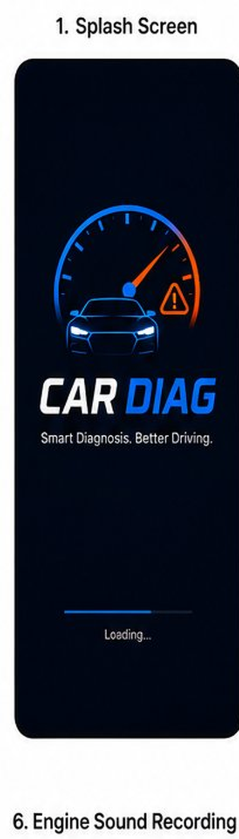
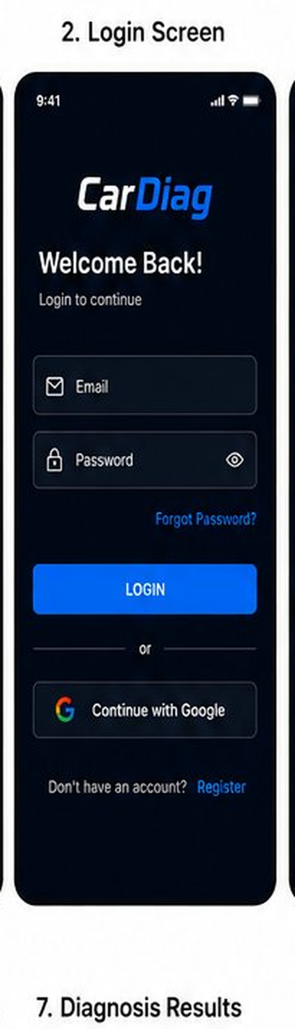
Screen 3 Register Screen | Mockup
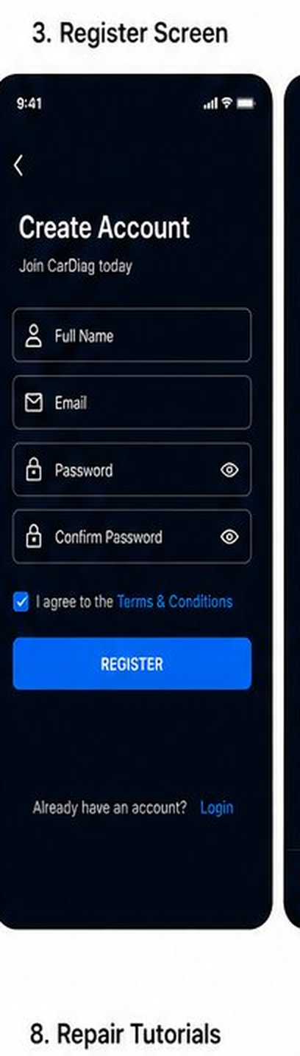
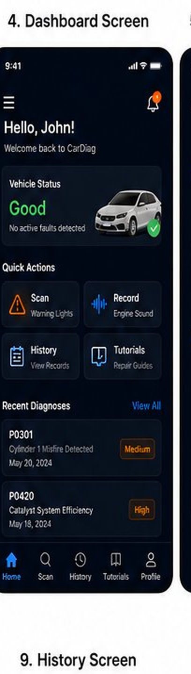
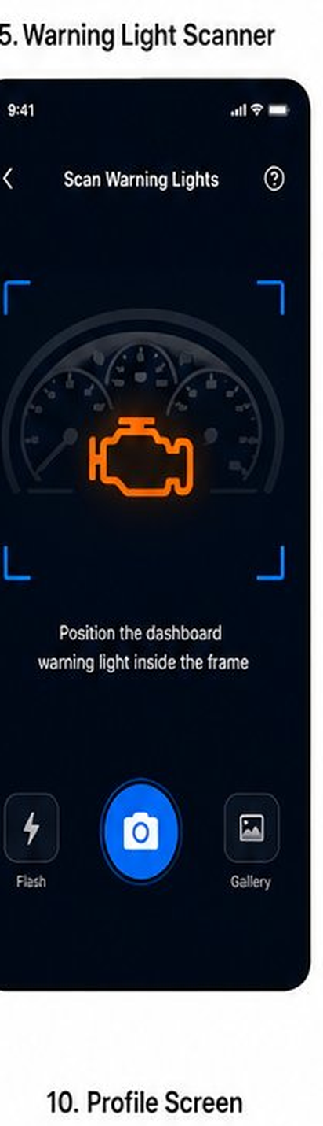
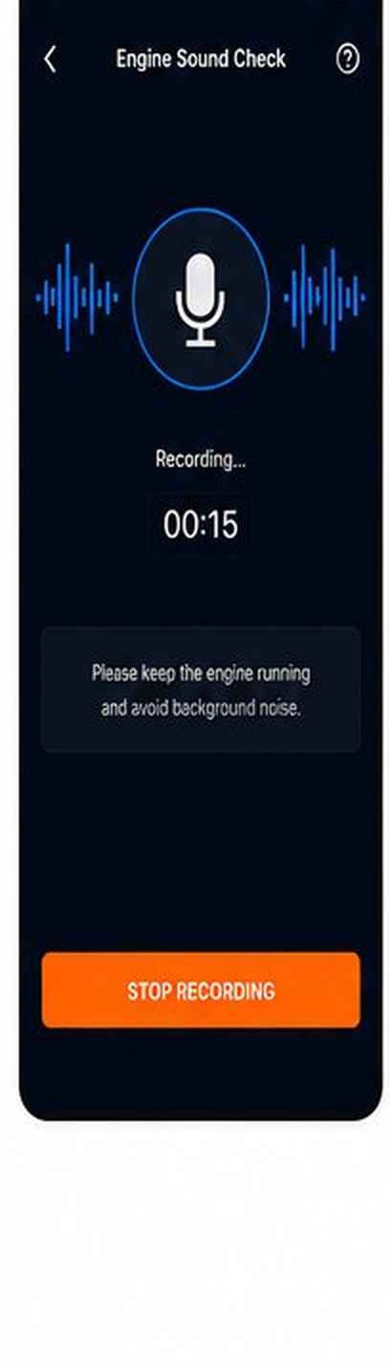
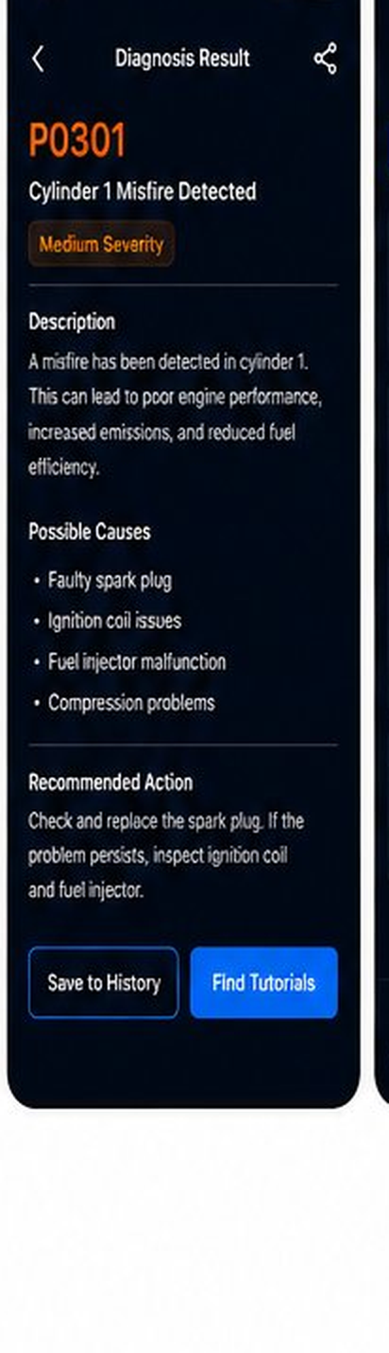
Screen 8 Repair Tutorials | Mockup
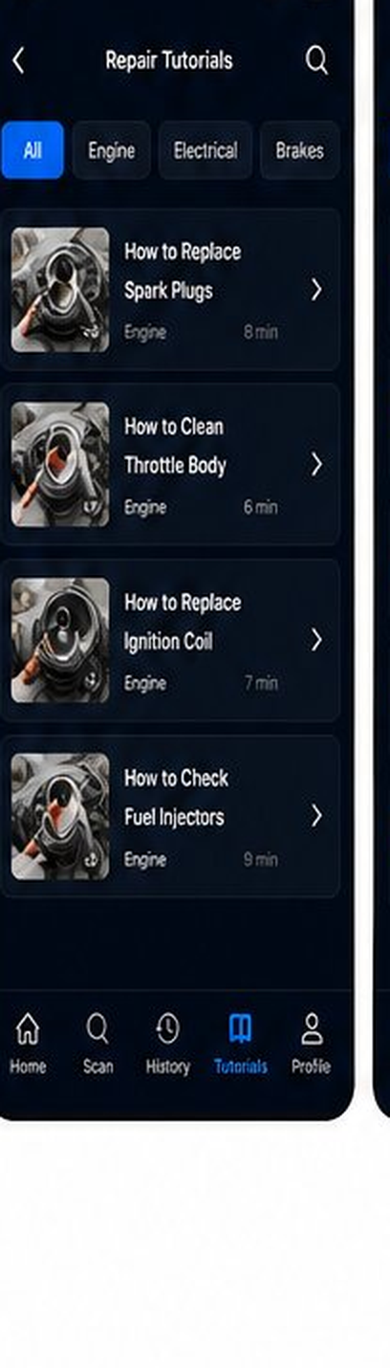
Screen 9 History Screen | Mockup
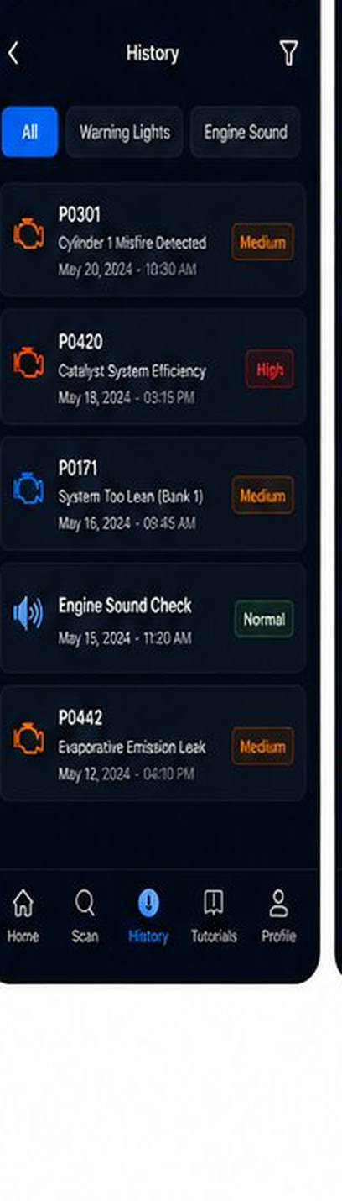

Screen 10 Profile Screen | Mockup
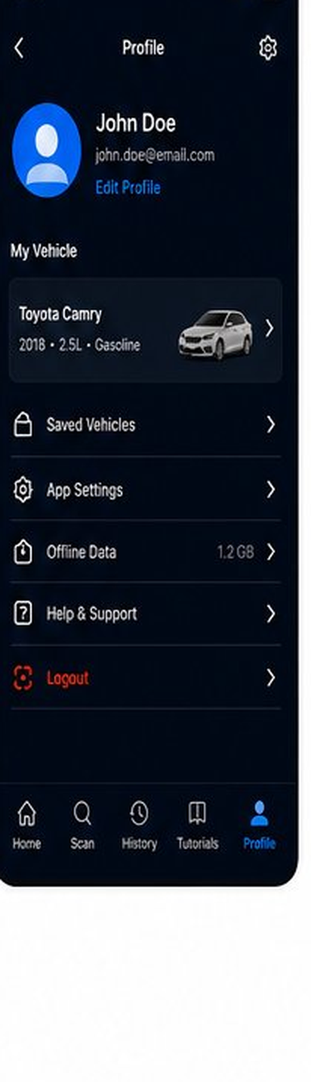

4. Frontend Implementation
This section documents the React Native implementation of the CarDiag application. It covers the project setup, folder structure, navigation configuration, individual screen implementations, and the reusable component library.
4.1 Project Setup CarDiag is built with React Native CLI. Unlike Expo, the React Native CLI gives full access to the native Android and iOS build systems, which is required for features such as Bluetooth OBD-II communication, background microphone recording, and native camera access.

4.1.1 Environment Requirements
The following tools must be installed on the development machine before initialising the project.

Tool | Version | Purpose
Node.js | 18.x or above | JavaScript runtime
npm | 9.x or above | Package manager
React Native CLI | Latest | Project initialisation and build commands
Android Studio | Latest stable | Android SDK, emulator, and build tools
Xcode | 14 or above | iOS simulator and build tools (macOS only)
JDK | 17 | Required by the Android build system (Gradle)
Git | Latest | Version control

4.1.2 Project Initialisation
The project was created using the React Native CLI init command with the TypeScript template. TypeScript was chosen over plain JavaScript because it provides static type checking, which reduces runtime errors and makes the codebase easier to maintain across the team.

4.2 Project Structure
The CarDiag project follows a feature-based folder structure. All source code lives inside the src folder, which is divided into subfolders by responsibility. This organisation keeps the codebase readable and makes it easy to locate any file as the project grows.

CarDiag/
├── android/ # Android native project files
├── ios/ # iOS native project files
├── src/ # All application source code
│ ├── assets/ # Images, fonts, icons
│ ├── components/ # Reusable UI components
│ ├── navigation/ # Navigation configuration
│ ├── screens/ # All application screens
│ ├── services/ # API calls and business logic
│ ├── store/ # Global state management
│ ├── theme/ # Colours, typography, spacing
│ └── utils/ # Helper functions
├── App.tsx # Root component

Some screenshots of codes:
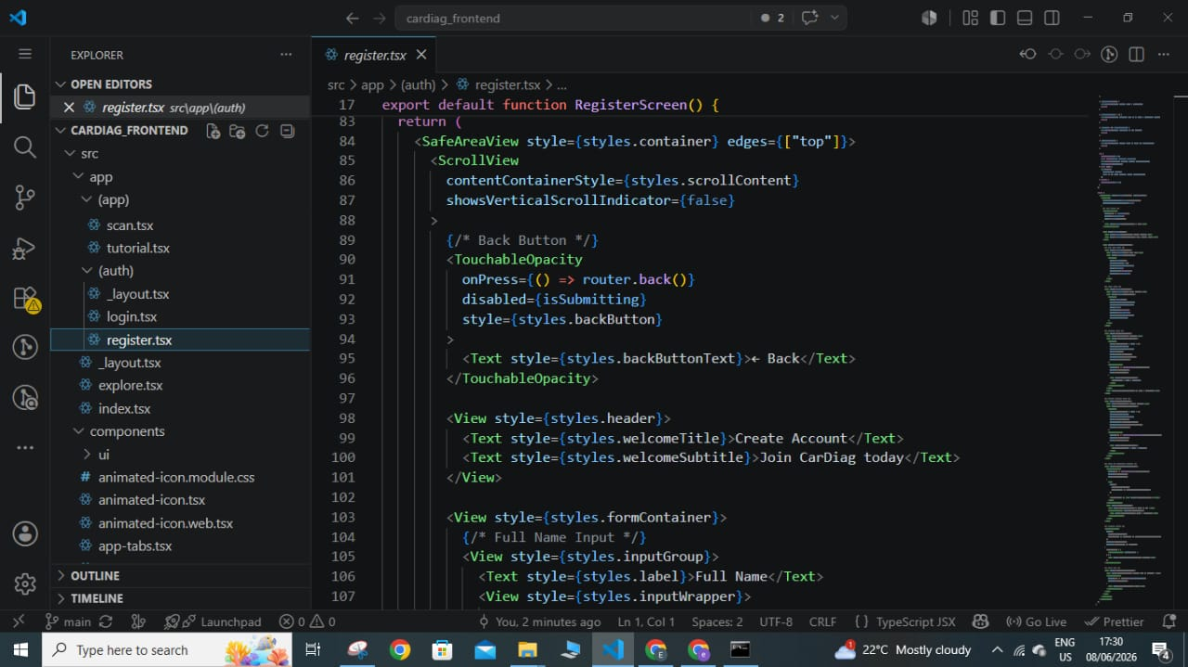
Code for the registration page
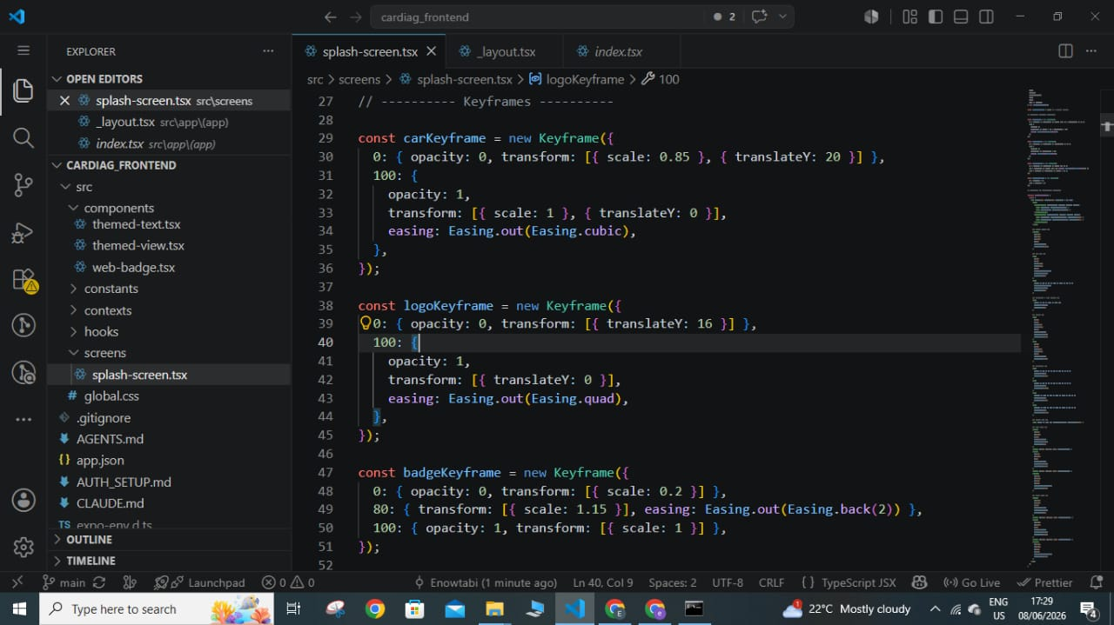
Code for the splash screen
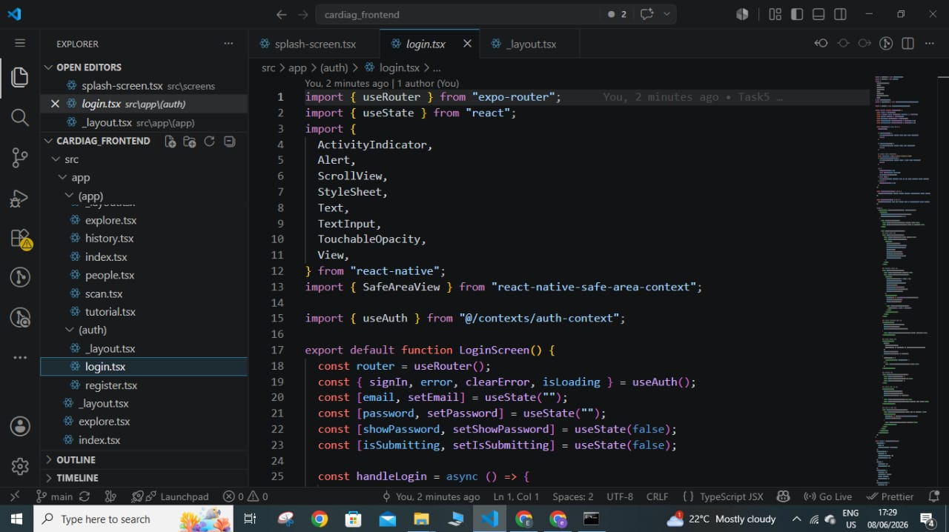
Code for the login page

4.3Screen Implementations

4.4 Testing

5. Conclusion
This report has documented the three main phases of the CarDiag development process for the current task: App Identity, Visual Design, and Frontend Implementation.
The App Identity section established the complete technical and visual foundation of the application, from the package name and SDK targets to the colour palette, typography, logo, and icon. These definitions ensure that CarDiag is consistent and recognisable across all platforms and contexts.
The Visual Design section translated the system requirements into a structured user interface through design principles, a component library, structural wireframes for all ten screens, and high-fidelity mockups. The dark theme, Electric Blue primary colour, and Warning Orange accent work together to communicate automotive technology and fault awareness clearly.
The Frontend Implementation section will document the React Native codebase once development is complete. It will cover the project structure, navigation configuration, screen-by-screen implementation, and reusable components.

